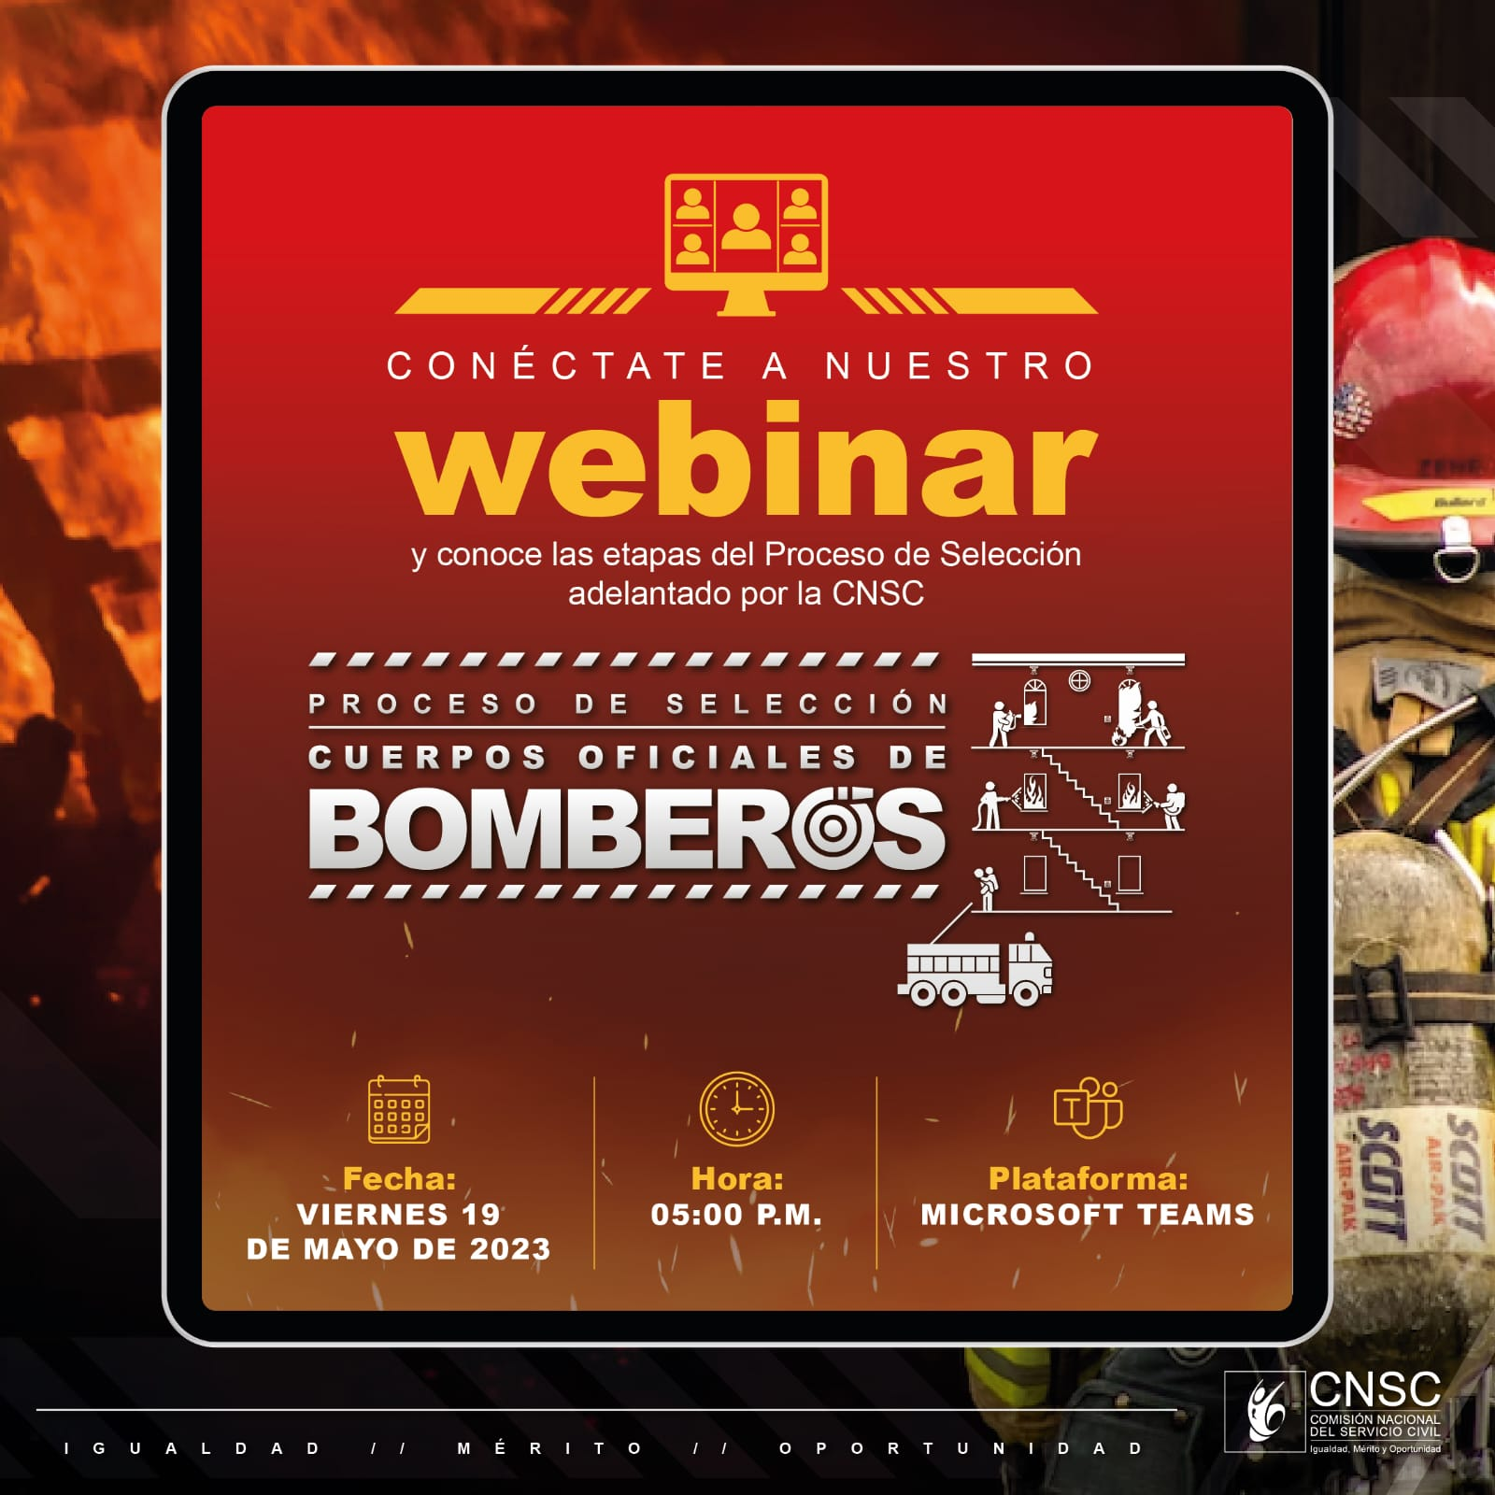

https://teams.microsoft.com/l/meetup-join/19%3ameeting_ZTE4MzA5Y2YtYWJkZC00YmMzLThlZWItZDFjMWU3ZGMwNmU3%40thread.v2/0?context=%7B%22Tid%22%3A%22073536cf-14f9-4a22-a54e-a4bef8a618fa%22%2C%22Oid%22%3A%2262504695-596a-47b0-848a-2dda5f419a60%22%2C%22IsBroadcastMeeting%22%3Atrue%2C%22role%22%3A%22a%22%7D&btype=a&role=a

